As way of illustration, the ICC framed the most popular places of arbitration between 2006 and 2013 in a chart.

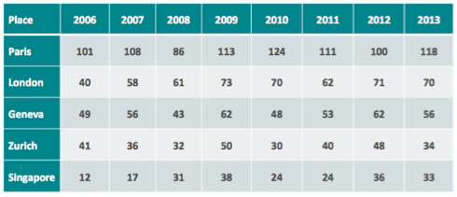

**Question 1 : Comment on whether the parties have agreed on the place of arbitration.**

*“All disputes relating to this contract shall be resolved by the ICC Court in Paris under its Rules of Arbitration.”*

*“All disputes arising out of or relating to this contract shall be resolved by arbitration under the ICC Rules of Arbitration utilizing the hearing facilities in Times Square, New York.”*

*“Any disputes arising from the interpretation of this contract shall be resolved by ICC arbitration in Paris. Language: English. Number of arbitrators: 3. Venue: to be agreed by the parties or, failing agreement, London.”*

*Guideline 4: The parties should select the place of arbitration. This selection should be based on both practical and juridical considerations.*

*Comments:*

1. The selection of the place (or ‘seat’) of arbitration involves obvious practical considerations: neutrality, availability of hearing facilities, proximity to the witnesses and evidence, the parties’ familiarity with the language and culture, willingness of qualified arbitrators to participate in proceedings in that place. The place of arbitration may also influence the profile of the arbitrators, especially if not appointed by the parties. Convenience should not be the decisive factor, however, as under most rules the tribunal is free to meet and hold hearings in places other than the designated place of arbitration.
2. The place of arbitration is the juridical home of the arbitration. **Close attention must be paid to the legal regime of the chosen place of arbitration because this choice has important legal consequences under most national arbitration legislations as well as under some arbitration rules.** While the place of arbitration does not determine the law governing the contract and the merits (see paragraphs 42-46 below), it does determine the law (arbitration law or *lex arbitri*) that governs certain procedural aspects of the arbitration, eg, the powers of arbitrators and the judicial oversight of the arbitral process. Moreover, the courts at the place of arbitration can be called upon to provide assistance (eg, by appointing or replacing arbitrators, by ordering provisional and conservatory measures, or by assisting with the taking of evidence), and may also interfere with the conduct of the arbitration (eg, by ordering a stay of the arbitral proceedings). Further, these courts have jurisdiction to hear challenges against the award at the end of the arbitration; awards set aside at the place of arbitration may not be enforceable elsewhere. Even if the award is not set aside, the place of arbitration may affect the enforceability of the award under applicable international treaties.
3. **As a general rule, the parties should set the place of arbitration in a jurisdiction (i) that is a party to the 1958 Convention on the Recognition and Enforcement of Foreign Arbitral Awards (known as the New York Convention), (ii) whose law is supportive of arbitration and permits arbitration of the subject matter of the contract, and (iii) whose courts have a track record of issuing unbiased decisions that are supportive of the arbitral process.**
4. An arbitration clause that fails to specify the place of arbitration will be effective, though undesirable. The arbitral institution, if there is one, or the arbitrators, will choose for the parties **if they cannot agree** on a place of arbitration after a dispute has arisen. (In *ad hoc* arbitration, however, if difficulties arise with the appointment of the arbitrators and no place of arbitration is selected, the parties may be unable to proceed with the arbitration unless courts in some country are willing to assist.) The parties should not leave such a critical decision to others.
5. **The parties should specify in their arbitration clause the ‘place of arbitration’, rather than the place of the ‘hearing’. By designating only the place of the hearing, the parties leave it uncertain whether they have designated the ‘place of arbitration’ for the purposes of applicable laws and treaties. Moreover, by designating the place of the hearing in the arbitration clause, the parties deprive the arbitrators of desired flexibility to hold hearings in other places, as may be convenient.**
6. *Recommended Clause:*  The place of arbitration shall be [city, country]
7. The place of arbitration is one of the most important matters to be addressed and specified in an arbitration clause in an international transaction. This determines *“*the rules of the game*”.* There are two concepts involved here. This is not only a geographical issue but also raises a critical legal issue with serious consequences for any future arbitration. First, it should be appreciated by the parties that in choosing a geographical location as the venue for the arbitration then that will carry with it the applicability of the laws of that jurisdiction to the extent that any mandatory laws will always apply to arbitrations conducted at that place and it may include laws relating to such critical matters as the removal of arbitrators.
8. Apart from the geographical considerations, the question of the legal situs of the arbitration needs to be considered. Where is the international arbitration taking place as a matter of legal theory? An international arbitration may take place physically in more than one location or jurisdiction at the same time. An international arbitration frequently takes place by videoconferencing involving people in a range of different jurisdictions. It is necessary in such circumstances for the parties to choose which arbitration law will regulate the procedural aspects of the arbitration as the common law “*does not recognize the concept of arbitral procedures floating in the transnational firmament unconnected with any municipal system of law.”*

This choice of the place of the arbitration is generally expressed as the choice of the “seat” of the arbitration. It is the parties’ agreement of the juridical home of the arbitration. The choice of the seat will have a major effect on any enforcement as the award is generally regarded as being made at the seat of the arbitration and the courts of that place as having primary supervisory responsibility for the arbitration and any award. The law of the seat selected by the parties may be a different law to that chosen by the parties as the law governing the merits of their dispute. The seat identifies *“the country whose job it is to administer, control or decide what control there is to be over an arbitration.”* There is an implied term in the parties agreement of the seat of the arbitration, that the courts of that place have exclusive supervisory jurisdiction. Accordingly an attempt to invoke the courts of another jurisdiction to set aside the award is in breach of the parties’ contractual rights and may be restrained by an anti-suit injunction.

1. Thus the choice of the seat *“is akin to an exclusive jurisdiction clause [n]ot only is there agreement to the arbitration itself but also to the courts of the seat having supervisory jurisdiction over [the] arbitration”* Any challenge to the award is likely to be made under the laws of the seat except where the challenge arises on an application for enforcement of the award under the New York Convention. *“It is the curial law which governs the validity of the award and challenges to it.”*
2. Apart from the general amenity and neutrality of a prospective venue of the arbitration, when selecting the location in which the arbitration is to take place, it is necessary to consider whether or not that place:
   1. (i)  has a modern, national legislation dealing with arbitration;
   2. (ii)  provides for minimal interference by domestic laws and the courts;
   3. (iii)  recognises a broad interpretation of what disputes can be arbitrated;
   4. (iv)  recognises the validity of the arbitration clause52;
   5. (v)  respects the parties’ autonomy to allow the parties the flexibility to vary  the arbitral process as the need arises. ;
   6. (vi)  allows the parties the freedom to use lawyers of choice who may not be admitted in that jurisdiction, eg s 29(2) of the International Arbitration Act 1974 confers this freedom; it states that a person *“while acting on behalf of a party to an arbitral proceeding ..., including appearing before an arbitral tribunal, shall not thereby be taken to have breached any law regulating admission to, or the practice of, the profession of the law within the legal jurisdiction in which the arbitral proceedings are conducted”;*
   7. (vii)  provides the parties with assistance from the local courts in aid of the arbitration e.g. on substantive matters such as granting and assisting with interim measures, and on procedural matters such as compelling the attendance of third persons to attend as witnesses and produce documents,53
   8. (viii)  ensures as far as is possible the enforceability of the award outside the country of origin.54

43. Once the seat has been chosen, additional care should be taken to express this choice precisely where the place or seat is in a country which does not have a unitary system of law such as a federation. In such a case it requires the specification of a particular city such as Melbourne or Sydney and not the federal state. If the parties were to choose Australia as the seat of the arbitration then the law of the seat would be uncertain as the law will depend on which state within Australia was intended by the parties.

* Hearings and meetings may be held at any convenient location (see ICC Art 18(2); ML Art 20(2)):

“*the arbitral tribunal may, unless otherwise agreed by the parties, meet at any place it considers appropriate for consultation among its members, for hearing witnesses, experts of the parties, or for inspection of goods, other property or documents*”.

* In practice, hearings and meetings are usually held at the seat.
* *Angela Raguz v Rebecca Sullivan*. 2000 Sydney Olympic Games. Seat Geneva, hearings in Sydney. Court of Appeal:

“*Commentators have pointed out that Article 20 [of the Model Law] makes sense when it is understood that there is a vital distinction between the so-called place (or seat) of arbitration and the place or places where the arbitrators may hold hearings, consultations… The common law recognises this distinction…*

* Holding the hearings elsewhere cannot change the legal seat.
* Singapore Court of Appeal in *PT Garuda Indonesia v Birgen Air.* Court of Appeal observed3:

“*It should be apparent from art 20* [Model Law] *that there is a distinction between ‘place of arbitration’ and the place where the arbitral tribunal carries on hearing witnesses, experts or the parties, namely the ‘venue of the hearing’. Where parties have agreed on the place of arbitration, it does not change even though the tribunal may need to hear witnesses or do any other things in relation to the arbitration in a different location.*”

3 PT Garuda Indonesia v Birgen Air [2002] 1 SLR 393, at 399. See also the discussion of changing the seat at Section 6.3.

* By agreement. Any words indicating choice. Eg ‘the seat of arbitration will be X’.
* Other language, even vague, will usually suffice unless there is conflicting locations in the clause. Careful not to confuse with the location or venue for hearings
* Failing agreement, default mechanism under rules or procedural law. Eg ICC Art 18(1); ML Art 20.
* ICC: seats of arbitration 2013 - literally all over the world:
  + Places of arbitration 2013: 63 countries, 104 different cities
    - European cities: 79 % (Paris 118, London 70, Geneva 56)
    - Asian cities: 11,84% (Hong Kong 14)
  + 11.5% of places fixed by the Court and the rest (88.5%) by the parties

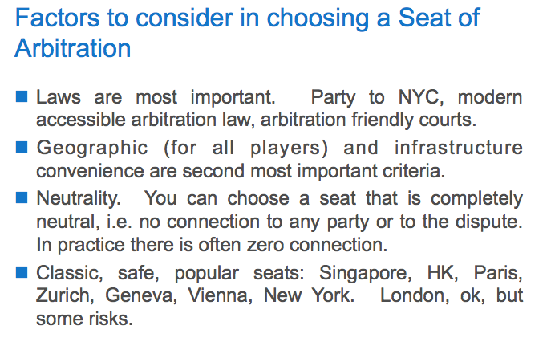

**Question 2**: A Canadian construction company asks your advice on whether to choose Modelania as the place of arbitration for a deal it is negotiating with a Turkish governmental authority specifically set up for the project in question. The deal involves the Canadian company building a state run cement factory in Southern Turkey.

The Canadian company asks you (i) whether Modelville is a suitable place of arbitration for this deal, (ii) whether it is necessary to choose an arbitral institution for an arbitration seated in Modelville and the advantages/disadvantages of doing so, (iii) which arbitration institution(s) can be chosen for an arbitration seated in Modelville, indicating which one you recommend and why, (iv) whether it is possible to opt out of all recourse against the award in Modelania and, if so/if not, what recourse there will be against the award, (v) what would be a suitable alternative seat of arbitration for this deal and what advantages might such place have over Modelville, (vi) any tips you have for what the arbitration clause for this specific deal might include, and (vii) any other comments or advice you have arising out of the facts provided.

1. **whether Modelville is a suitable place of arbitration for this deal**

* IBA Guidelines – Guideline 4
  + As a general rule, the parties should set the place of arbitration in a jurisdiction

1. that is a party to the 1958 Convention on the Recognition and Enforcement of Foreign Arbitral Awards (known as the New York Convention),
2. whose law is supportive of arbitration and permits arbitration of the subject matter of the contract, and
3. whose courts have a track record of issuing unbiased decisions that are supportive of the arbitral process.

* First criteria: we don’t know whether or not Modelania is a party to the 1958 Convention on the Recognition and Enforcement of Foreign Arbitral Awards
  + <http://www.uncitral.org/uncitral/fr/uncitral_texts/arbitration/NYConvention_status.html> : no mention so probably not
* Second : no information as with regards to whether Modelania is supportive or not of arbitration and permits arbitration of the subject matter of the contract
  + Arbitration Act 2000
  + updated so to include the 2006 amendments
    - in this regards adoption of the most favorable close to arbitration : Article 7 option II
  + in 2000 as well Modelania established its own arbitration administering institution called the Modelania Association For International Arbitration : UNCITRAL rules with some amendments

However, one could argue as well that Modelania has adopted arbitration regulation quite lately

* Third : no information regarding Modelania : we cannot answer to the question as to whether Modelania’s courts issue unbiased decisions that are supportive of the arbitral process
  + We just know that local lawyers claim that there are about 5-8 international arbitrations setaed there per year : very few
* Discorage from choosing Modelania

**6.2 Factorstoconsiderinchoosingaseatofarbitration**

Some might cynically suggest that the most important factors when choosing a seat of arbitration depend on whom you ask. The parties’ lawyers will probably want a seat the location of which is easily accessible and which has an arbitration law with which they are familiar. The parties themselves may be interested in the neutrality of the venue and the financial costs of arbitrating there. Everybody involved might consider it important that the seat of arbitration be the place of residence of the chairperson of the arbitral tribunal or the sole arbitrator. This may reduce costs and ensure that the chairperson has a good knowledge of the local arbitration law.

**Realistically, the most important factor is the presence of laws and courts that are favourable to international arbitration**.97

* First, the seat should be a party to the **New York Convention**. This is important for enforcement of any resulting award in other New York Convention countries because many jurisdictions have adopted the New York Convention with reciprocity reservations.98
* Second, **the seat’s arbitration law should provide for the desired level of judicial interference and control** (that is, the desired level of delocalisation).
  + The trend in modern international arbitration laws such as Model Law jurisdictions is for a very limited degree of judicial control, or highly delocalised arbitration proceedings.
* Further, the quality of the judiciary and the court system should be considered. If it becomes necessary during arbitration proceedings to approach a court for assistance, will that court be able to deal with the matter quickly, efficiently and predictably?

**Geographic and infrastructure convenience should be the second main criteria after the quality of the legal system and courts.**

* The seat of arbitration should be geographically convenient for most people who will be involved in an arbitration; that is parties, witnesses, arbitrators and lawyers
* Also important is that there are international flights and facilities such as appropriate hotels and rooms for conducting the arbitration hearings.

**The third consideration concerns the neutrality of the seat.**

* Usually contracting parties will prefer a seat that is outside the jurisdictions of any contracting party.
* The ability to choose a totally neutral seat – that is a seat with no connection whatsoever to the parties or the underlying dispute – is one of the many advantages of international arbitration over litigation. In international litigation it is rarely possible for parties simply to select any court that they want to resolve their dispute. Depending on the rules of that particular court, there usually has to be a connection between the court and the parties or the dispute in order for the court to accept jurisdiction. This is not true for arbitration. There is often no requirement that the chosen seat of arbitration be in any way linked to one of the parties or the underlying transaction.

HOLMES

1. Thus the choice of the seat *“is akin to an exclusive jurisdiction clause [n]ot only is there agreement to the arbitration itself but also to the courts of the seat having supervisory jurisdiction over [the] arbitration”* Any challenge to the award is likely to be made under the laws of the seat except where the challenge arises on an application for enforcement of the award under the New York Convention. *“It is the curial law which governs the validity of the award and challenges to it.”*
2. Apart from the general amenity and neutrality of a prospective venue of the arbitration, when selecting the location in which the arbitration is to take place, it is necessary to consider whether or not that place:
   1. (i)  has a modern, national legislation dealing with arbitration;
   2. (ii)  provides for minimal interference by domestic laws and the courts;
   3. (iii)  recognises a broad interpretation of what disputes can be arbitrated;
   4. (iv)  recognises the validity of the arbitration clause52;
   5. (v)  respects the parties’ autonomy to allow the parties the flexibility to vary  the arbitral process as the need arises. ;
   6. (vi)  allows the parties the freedom to use lawyers of choice who may not be admitted in that jurisdiction, eg s 29(2) of the International Arbitration Act 1974 confers this freedom; it states that a person *“while acting on behalf of a party to an arbitral proceeding ..., including appearing before an arbitral tribunal, shall not thereby be taken to have breached any law regulating admission to, or the practice of, the profession of the law within the legal jurisdiction in which the arbitral proceedings are conducted”;*
   7. (vii)  provides the parties with assistance from the local courts in aid of the arbitration e.g. on substantive matters such as granting and assisting with interim measures, and on procedural matters such as compelling the attendance of third persons to attend as witnesses and produce documents,53
   8. (viii)  ensures as far as is possible the enforceability of the award outside the country of origin.54

43. Once the seat has been chosen, additional care should be taken to express this choice precisely where the place or seat is in a country which does not have a unitary system of law such as a federation.

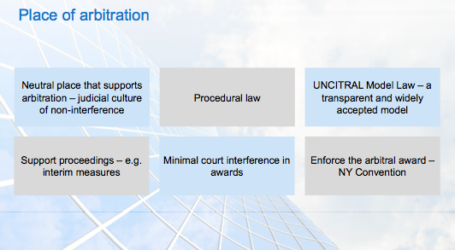

**(ii) whether it is necessary to choose an arbitral institution for an arbitration seated in Modelville and the advantages/disadvantages of doing so,**

1. **Guideline 1: The parties should decide between institutional and *ad hoc* arbitration.**

*Guideline 1: The parties should decide between institutional and ad hoc arbitration.*

*Comments:*

1. The first choice facing parties drafting an arbitration clause is whether to opt for institutional or *ad hoc* arbitration.
2. In institutional (or administered) arbitration, an arbitral institution provides assistance in running the arbitral proceedings in exchange for a fee. The institution can assist with practical matters such as organizing hearings and handling communications with and payments to the arbitrators. The institution can also provide services such as appointing an arbitrator if a party defaults, deciding a challenge against an arbitrator and scrutinizing the award. The institution does not decide the merits of the parties’ dispute, however. This is left entirely to the arbitrators.
3. Institutional arbitration may be beneficial for parties with little experience in international arbitration. The institution may contribute significant procedural ‘know how’ that helps the arbitration run effectively, and may even be able to assist when the parties have failed to anticipate something when drafting their arbitration clause. The services provided by an arbitral institution are often worth the relatively low administrative fee charged.
4. If parties choose administered arbitration, they should seek a reputable institution, usually one with an established track record of administering international cases. The major arbitral institutions can administer arbitrations around the world, and the arbitral proceedings do not need to take place in the city where the institution is headquartered.
5. In *ad hoc* (or non-administered) arbitration, the burden of running the arbitral proceedings falls entirely on the parties and, once they have been appointed, the arbitrators. As explained below (Guideline 2), the parties can facilitate their task by selecting a set of arbitration rules designed for use in *ad hoc* arbitration. Although no arbitral institution is involved in running the arbitral proceedings, as explained below (Guideline 6), there still is a need to designate a neutral third party (known as an ‘appointing authority’) to select arbitrators and deal with possible vacancies if the parties cannot agree.

* choice between ad hoc or institutional: not necessary however
  + if choice of an institutional arbitration : need to be careful regarding the choice of the institution
  + if choice of an ad hoc arbitration : adoption of rules such as the UNCITRAL Arbitration rules and choice of a neutral authority (Guideline 6)

**Powerpoint :**

International Arbitral Institutions

􏰂Do not need one (except mainland China)

􏰂Matter of choice whether and which

􏰂Great variation in size, approach, quality

􏰂Be very cautious about choosing smaller ones

􏰂Larger ones (especially ICC) are also important industry players organising publications, conferences and training, producing notes and guidelines etc.

As Thomas Carbonneau explains:

“[Ad hoc arbitration*] places a substantial burden upon the parties to cooperate in the circumstances of dispute. The expectation of cooperation is likely to be unrealistic. Moreover, arbitral institutions have a good professional track record and have significant experience in the administrative aspects of arbitrations. Unless the parties themselves have substantial expertise in the arbitration process, institutional arbitration becomes a virtual necessity. Also, an award rendered under the auspices of a recognized arbitral institution may have a greater likelihood of enforcement for reasons of institutional reputation. The real question involves choosing among the arbitral institutions.*”

International Arbitral Institutions

􏰂PWC/ QM study mentioned earlier found:

􏰃86% of awards that were rendered over the last ten years were under the rules of an arbitration institution, while 14% were under ad hoc arbitrations’.

􏰃ICC is the preferred institution, with 45% of participating corporations preferring the ICC. This was followed by the AAA-ICDR (16%) and the LCIA (11%)

􏰃In the 2010 survey, the preference for ICC increased to 50% of all participants

Services offered by institutions at the higher supervised end may include:

􏰃  checking that there is a prima facie arbitration agreement (certain institutions only)

􏰃  (appointing arbitrators if a party fails to appoint one, or if the two party-appointed arbitrators(or the parties themselves) cannot agree on the chair-person (or sole arbitrator)

􏰃  removing and replacing an arbitrator who has become unable to complete his or her role for any reason

􏰃  deciding challenges as to the independence and/or impartiality of an arbitrator;

􏰃  keeping an up-to-date file on the arbitration proceedings

􏰃  scrutinising the arbitration award before it is finalised (certain  institutions only)

􏰃  managing the administrative and financial aspects of the arbitration.

**Texte Malcolm Holmes**

1. Those arguing in favour of institutional arbitration point to the procedures and practices embodied in the institution’s arbitration rules, which have been developed over time and have benefited from first hand experience accumulated over time. Nevertheless, the rules of the newer arbitral institutions such as ACICA have incorporated the lessons and practices from the more established institutions and reflect current best practice.
2. Arbitration institutions justifiably claim an advantage over ad hoc arbitration through the institutional support and administrative services, which are provided to the parties and the arbitrator. Some proudly refer to their practice of independent scrutinizing or checking the awards before they are made and issued to the parties. A more persuasive argument in support of institutional arbitration is unspoken advantage gained when it comes to enforcing the award from the enhanced integrity and imprimatur of an award which emanates from the processes of a well known arbitral institution as compared to an award emanating from an ad hoc arbitration process.

On the other hand, an ad hoc arbitration agreement ostensibly allows the parties to draft an arbitration clause which may be tailored to the meet the needs of the parties and their particular transaction. The difficulty with this however is that, as the needs of the parties sometimes only become manifest when the disputes subsequently arise, the drafting of an arbitration clause appears to require the benefit of hindsight.

15. The reality is that most arbitration clauses are somewhere in between an ad hoc agreement and an arbitral institution’s recommended clause. Even in the case of institutional arbitration, parties tend to vary or modify the template clause in an effort to customise the clause to meet their particular needs and circumstances.19 Although it may seem unnecessary, if an arbitration institution is involved, care should be taken to ensure that matters of detail are attended to such as ensuring that the institution exists and that the correct name of the arbitration institution mentioned in the clause is used.

**(iii) which arbitration institution(s) can be chosen for an arbitration seated in Modelville, indicating which one you recommend and why,,**

* MAFIA:
  + Applying the MAFIA Rules: UNCITRAL Arbitration rules
* ICC:
* ICSID:

If institutional arbitration is desired, the parties must choose a particular arbitral institution and refer to it in their arbitration clause. Parties ordinarily rely on one of a few established international arbitral institutions. This avoid the confusion and uncertainty that comes from inexperienced arbitral institutions or appointment and administrative efforts.

All leading international arbitral institutions are prepared to, and routinely do, administer arbitrations seated almost anywhere in the world, and not merely in the place where the institutions itself is located. There is therefore no need to select an arbitral institution headquarters in the parties’ desired arbitral seat.

The service rendered by professional arbitration institutions comes at a price, which is in addition to the fees and expenses of the arbitrators. Every arbitral institution has a fee schedule that specifies what that price is. The amounts charged by institutions for particular matter vary significantly, as does the basis for calculating such fees.

All leading arbitral institutions periodically revise their institutional arbitration rules.

* International Chamber of Commerce International Court of Arbitration

Established in Paris in 1923, the ICC remains the world’s leading international commercial arbitration institution and has less of a national character than any other leading arbitral institution

The ICC’s annual caseload exceeds XXX cases per year.

Most of these disputes are international disputes, involving very substantial sums.

The ICC has promulgated a set of ICC Rules of Arbitration (revised in 2012). Under the ICC Rules, the ICC (through the International Court of Arbitration (“ICC Court”)) is extensively involved in the administration of individual arbitrations. Among other things, the ICC Court and its Secretariat are responsible for service of the initial Request for Arbitration, fixing and receiving payment of advances on costs of the arbitration by the parties, confirming the parties’ nomination of arbitrators, appointing arbitrators if a Party defaults or if the parties are unable to agree upon a presiding arbitrator or sole arbitrator, considering challenges to the arbitrators including on the basis of lack of independence and impartiality, reviewing and approving the so called “Terms of Reference”, which define the issues and procedures for the arbitration, reviewing tribunal’s draft award for formal and other defects, and fixing the arbitrators’ compensation.

The ICC Court is an administrative body that acts in a supervisory and appointing capacity under the ICC Rules.

ICC arbitration can be and are seated almost anywhere in the world.

In XXX, ICC arbitration were conducted in XX different countries.

The ICC rules are broadly similar to the UNCITRAL Rules in providing a broad procedural framework for the arbitral proceedings.

As with most other institutional rules, only a procedural framework is provided, with the parties and arbitrators being accorded substantial freedom to adopt procedures tailored to particular disputes.

Unusually, the ICC Rules require both a Terms of Reference and procedural timetable to be adopted by the Tribunal at the outset of the proceedings and that an award be rendered within six months (absent extensions which are freely granted). Also unusually, the ICC Rules provide for the ICC Court to review draft awards before they are finalized and executed by the arbitrators.

The ICC administrative fees are based on the amount in dispute between the parties. With respect to arbitrators’ fees, the ICC Rules fix both a minimum and a maximum amount in dispute between the parties.? The ICC Rules require that the parties pay an advance on the costs of the arbitration calculated by the ICC Court. The advance in costs is equally divided between, the claimant and the respondent, although one party may pay the full amount in order to enable the arbitration to proceed if the other party defaults.

* London Court of International Arbitration

Second most popular European institution in the field of international commercial arbitration.

* American Arbitration Association and International Center for Dispute Resolution

The AAA is the leading US arbitral institution and reportedly handles one of the largest numbers of arbitral disputes in the world.

* ICSID:

The International Center for the Settlement of Investment Disputes is a specialized arbitration institution, established pursuant to the so-called ICSID Convention of 1965. The ICSID is designed to facilitate the settlement of investment disputes ie legal dispute[s] arising directly out of investment[s]

* MAFIA

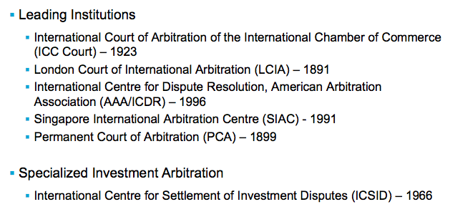

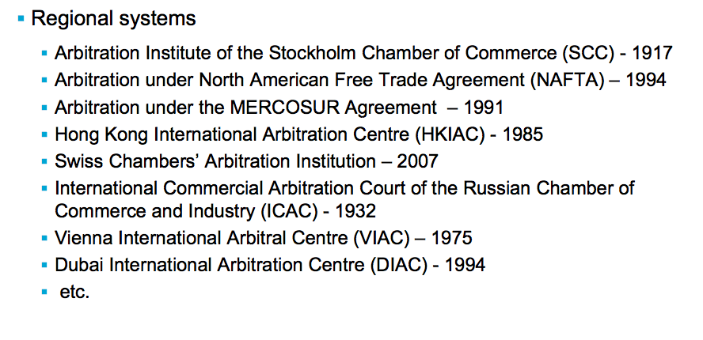

**Parties’ autonomy—paragraphs *(d)* and *(e) Non-mandatory provisions—paragraph* (d)**

6. Party’s autonomy is an important principle of the Model Law, illustrated by the high number of provisions in the Model Law referring to the agreement of the par- ties.52 Autonomy of the parties in determining the rules of procedure is of special importance in international cases since it allows the parties to select or tailor the rules accord- ing to their specific wishes and needs, unimpeded by tra- ditional and possibly conflicting domestic concepts, thus obviating the risk of frustration or surprise. Courts may have adopted differing approaches in the determination of the non-mandatory character of certain provisions of the

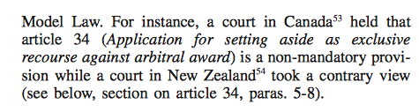

**(iv) whether it is possible to opt out of all recourse against the award in Modelania and, if so/if not, what recourse there will be against the award,**

*Chapter VII. Recourse against award . . . . . . . . . . . . . . . . . . . . . . . . . . . . . . . . .* 19

Article 34. Application for setting aside as exclusive recourse against arbitral award . . . . . . . . . . . . . . . . . . . . . . . . . . . . . . . . . . . . . . 19

CHAPTER VII. RECOURSE AGAINST AWARD

*Article 34. Application for setting aside as exclusive recourse against arbitral award*

(1) Recourse to a court against an arbitral award may be made only by an application for setting aside in accordance with paragraphs (2) and (3) of this article.

(2) An arbitral award may be set aside by the court specified in article 6 only if:

*(a)* the party making the application furnishes proof that:

(i) a party to the arbitration agreement referred to in article 7 was under some incapacity; or the said agreement is not valid under the law to which the parties have subjected it or, failing any indication thereon, under the law of this State; or

1. (ii)  the party making the application was not given proper notice of the appointment of an arbitrator or of the arbitral proceed- ings or was otherwise unable to present his case; or
2. (iii)  the award deals with a dispute not contemplated by or not fall- ing within the terms of the submission to arbitration, or contains decisions on matters beyond the scope of the submission to arbitration, provided that, if the decisions on matters submitted to arbitration can be separated from those not so submitted, only that part of the award which contains decisions on matters not submitted to arbitration may be set aside; or
3. (iv)  the composition of the arbitral tribunal or the arbitral proce- dure was not in accordance with the agreement of the parties, unless such agreement was in conflict with a provision of this Law from which the parties cannot derogate, or, failing such agreement, was not in accordance with this Law; or

*(b)* the court finds that:

1. (i)  the subject-matter of the dispute is not capable of settlement  by arbitration under the law of this State; or
2. (ii)  the award is in conflict with the public policy of this State.

(3) An application for setting aside may not be made after three months have elapsed from the date on which the party making that application had received the award or, if a request had been made under article 33, from the date on which that request had been disposed of by the arbitral tribunal.

(4) The court, when asked to set aside an award, may, where appropriate and so requested by a party, suspend the setting aside proceedings for a period of time determined by it in order to give the arbitral tribunal an opportunity to resume the arbitral proceedings or to take such other action as in the arbitral tribunal’s opinion will eliminate the grounds for setting aside.

**Modelania:** “may agree that the award shall be subject to appeal in case there is a fundamental mistake in applying the law” => possible to agree on an appeal if wrongful application of the law

However, in the absence of agreement, the award shall be final

If opt out: procedure for setting aside the award as contained in Article 34 of the Model Law

**(v) what would be a suitable alternative seat of arbitration for this deal and what advantages might such place have over Modelville,**

Paris, Ldn, NY,…



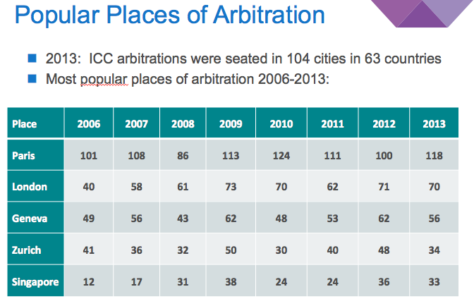

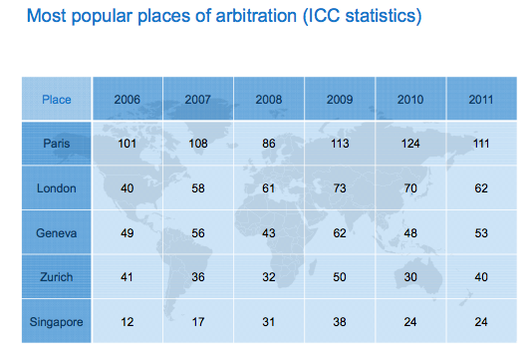

Article 34 of the Model Law deals with applications to set aside awards. Lew, Mistelis and Kro ̈ll state that ‘[i]n principle, court control over an arbitration award in challenge proceedings can never be excluded’.131 Some jurisdictions do, however, allow parties to limit the power of courts to set aside awards.132 Those exceptions aside, Article 34 can be considered mandatory. Additionally, it is uncertain whether parties would be permitted to add further grounds upon which courts could review or set aside an award, such as error of law. In a 2008 US Supreme Court decision *Hall Street Associates LLC v Mattel Inc*,133 it was held that parties could not add grounds to those stated in the Federal Arbitration Act. How countries in this region would react when faced with the same issue is not clear, especially as the domestic arbitration laws of several jurisdictions (which international parties can opt into) generally permit expanded grounds of judicial review and/or appeals.

**(vi) any tips you have for what the arbitration clause for this specific deal might include, and**

* IBA guidelines => elements that must be contained
  + Don’t forget the language
  + ?...
* Therefore Use of ICC or UNCITRAL model clauses
* + Confidentiality

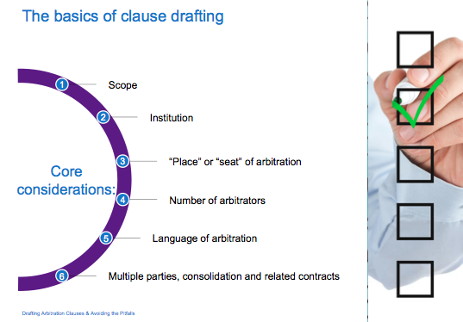

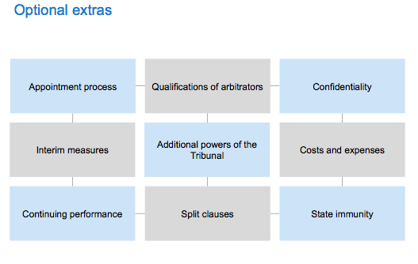

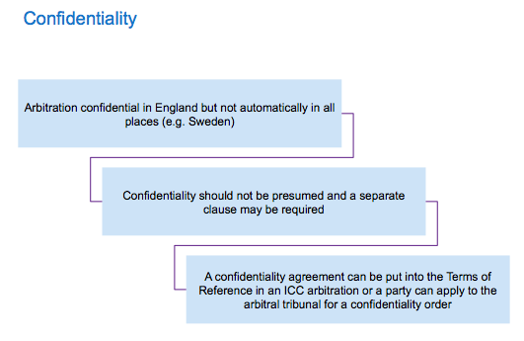

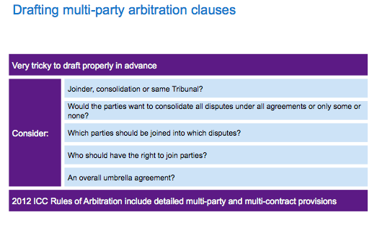

**(vii) any other comments or advice you have arising out of the facts provided.**

* turkey : joinder ?
  + provide a way to attract the state to the Arbitration
  + icsid?

**SOVEREIGN STATE PARTY TO THE CONTRACT**

1. Where a sovereign state or a state instrumentality is a party to the arbitration agreement, the nationality of the arbitrators is a relevant consideration. One of the advantages of arbitration is that “*arbitration is part of no State’s judicial system*”.40 Arbitration is a creature that owes its existence to the will of the parties alone. One of its advantages is that the parties voluntarily choose the arbitrator either directly or indirectly through their arbitration agreement. Where a state or a state entity is a party it is advisable to adopt a negative qualification for any arbitrator, i.e. an arbitrator may not be of the same nationality as any party to the contract.

By agreeing to arbitration, a sovereign state is thereby taken to have waived any sovereign immunity which would prevent the state being bound by that process, however another issue which arises where a state is a party to a contract, is the question of waiver of any sovereign immunity in relation to the assets which may be involved in the enforcement of any resulting arbitral award. Written consent by a state to a dispute being arbitrated does not also amount to consent to the enforcement of any award or waiver of state immunity on the execution of the award against particular state owned assets41. Accordingly, if possible and practical, a waiver of immunity against execution should also be obtained at the time of contracting and obtaining the consent of the state to submit any dispute to arbitration.

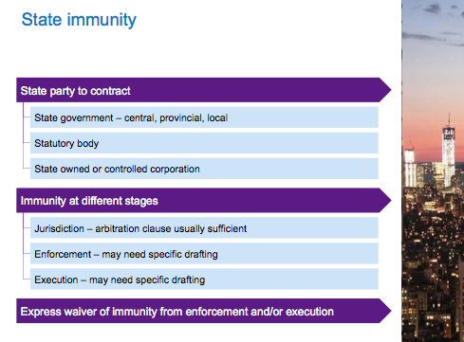

**Question 3**: Article 25 of a fictitious country's Arbitration Law provides as follows:

*“Unless otherwise agreed between the parties to the dispute, the award shall be in the Arabic language; otherwise, the award, shall at the time of filing, be accompanied by a legalized translation thereof.”*

In an arbitration being administered under the ICC Rules, the parties have not agreed on the language of arbitration (either in their arbitration agreement or subsequently, following prompts by the Arbitral Tribunal). The contract containing the arbitration agreement is in English. The Claimant is German and the Respondent is from Qatar. The dispute concerns a sale of commercial properties in Modelania. The Claimant requests that English be the language of the arbitration, whereas the Respondent insists on Arabic, referring to Article 25 of the Arbitration Law.

Comment on whether the Arbitral Tribunal is empowered to rule on the question of language, and if so whether it may and should rule that English, Arabic or another language shall apply.

ARTICLE 20 of the ICC Rules

Language of the Arbitration

In the absence of an agreement by the parties, **the arbitral tribunal shall determine the language or languages of the arbitration**, due regard being given to all relevant circumstances, including the language of the contract.

* not only empowered but required to rule on the question of language
* take into account all the relevant circumstances:
  + including the language of the contract
    - English
    - + on peut presuppose que les correspondances entre les deux parties ont été faites en anglais
  + therefore laws of the place of enforcement
    - on presuppose que le fictious country is Modelania
      * Art 25: “unless otherwise agreed by the parties” => parties failed to reach an agreement
      * “the award shall at the time of filing be accompanied by a legalized translation thereof”
  + translation in Arabic of the award

*Guideline 7: The parties should specify the language of arbitration.*

*Comments:*

1. Arbitration clauses in contracts between parties whose languages differ, or whose shared language differs from that of the place of arbitration, should ordinarily specify the language of arbitration. In making this choice, the parties should consider not only the language of the contract and of the related documentation, but also the likely effect of their choice on the pool of qualified arbitrators and counsel. Absent a choice in the arbitration clause, it is for the arbitrators to determine the language of arbitration. **It is likely that the arbitrators will choose the language of the contract or, if different, of the correspondence exchanged by the parties. Leaving this decision to the arbitrators could cause unnecessary cost and delay.**
2. Contract drafters are often tempted to provide for more than one language of arbitration. The parties should carefully consider whether to do so. Multi-lingual arbitration, while workable (there are numerous examples of proceedings conducted in both English and Spanish, for example), may present challenges depending on the languages chosen. There may be difficulties in finding arbitrators who are able to conduct arbitration proceedings in two languages, and the required translation and interpretation may add to the costs and delays of the proceedings. A solution may be to specify one language of arbitration, but to provide that documents may be submitted in another language (without translation).
3. *Recommended Clause:*

The language of the arbitration shall be [...].

**Gaillard Fouchard Goldman : pp678 et 679**

« the arbitration will take place in the language or languages chosen by the parties or, if the parties fail to make such a choice, by the arbitral tribunal. Where there is no indication to the contrary, the languages chosen by the arbitrators will usually be that of the contract containing the arbitration agreement. »

In ICC arbitration, Article XX….

« In some cases, arbitrations are held in several languages simultaneously. Given the considerable expense involved –an expense that is often underestimated by the parties- caution should be exercised before choosing that option »

pp.760-761

« In principle the award is made in the language of the arbitral proceedings. The parties could of course agree other wise and ask for the award be made in a different language.

If and when enforcement is sought, the award may have to be translated into the language of the country where it is to be enforced under Article IV paragraph 2 d the 1958 NYC »

**Gary Born :** p2450

« typically, parties will specify (through their arbitration agreement) the language of the arbitration, which will impliedly extend to the arbitral award. Where the parties have not selected the language of the arbitration, the tribunal will do so, again generally impliedly encompassing the language of the award. In both instances, failure to make the award in the requisite language may well constitute a defect of form and a basis for annulment or non recognition of the award. It is possible that national law in the arbitral seat would impose language requirements on the award. If this is the case, the award would be exposed to annulment or non recognition if it were not in the required language (subject to arguments that, where the parties had otherwise agreed, national law was contrary to article II and V(1)(d) of the NYC)

Gary B. Born , *International Arbitration: Cases and Materials*,